Year 11 Physics
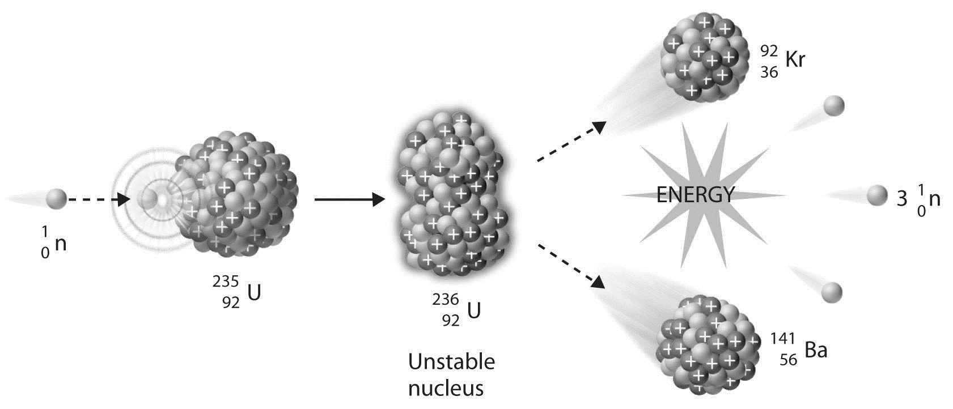
Nuclear

(Puiu, 2017)
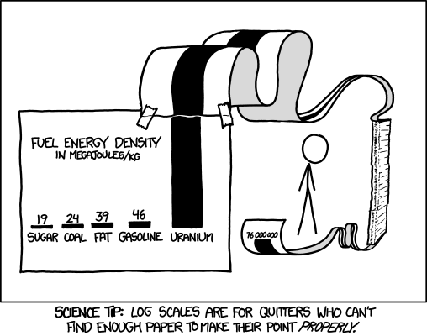
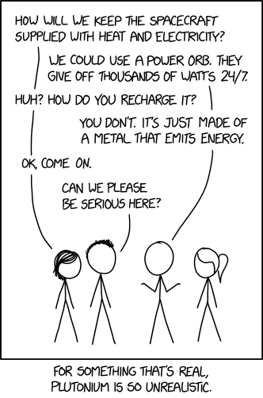
https://xkcd.com/2115/ https://xkcd.com/1162/

Name:

SCSA ATAR Syllabus
https://senior-secondary.scsa.wa.edu.au/syllabus-and-support-materials/science/physics

Science Understanding
- the nuclear model of the atom describes the atom as consisting of an extremely small nucleus which contains most of the atom’s mass, and is made up of positively charged protons and uncharged neutrons surrounded by negatively charged electrons
- nuclear stability is the result of the strong nuclear force which operates between nucleons over a very short distance and opposes the electrostatic repulsion between protons in the nucleus
- some nuclides are unstable and spontaneously decay, emitting alpha, beta (+/-) and/or gamma radiation over time until they become stable nuclides
- each species of radionuclide has a half-life which indicates the rate of decay This includes applying the relationship $N=N_{0}{(\frac{1}{2})}^{n}$
- alpha, beta and gamma radiation have different natures, properties and effects
- the measurement of absorbed dose and dose equivalence enables the analysis of health and environmental risks This includes applying the relationships $absorbed dose=\frac{E}{m}$, $dose equivalent=absorbed dose×quality factor$
- Einstein’s mass/energy relationship relates the binding energy of a nucleus to its mass defect This includes applying the relationship $∆E=∆mc^{2}$
- Einstein’s mass/energy relationship also applies to all energy changes and enables the energy released in nuclear reactions to be determined from the mass change in the reaction This includes applying the relationship $∆E=∆mc^{2}$
- alpha and beta decay are examples of spontaneous transmutation reactions, while artificial transmutation is a managed process that changes one nuclide into another
- neutron-induced nuclear fission is a reaction in which a heavy nuclide captures a neutron and then splits into smaller radioactive nuclides with the release of energy
- a fission chain reaction is a self-sustaining process that may be controlled to produce thermal energy, or uncontrolled to release energy explosively if its critical mass is exceeded
- nuclear fusion is a reaction in which light nuclides combine to form a heavier nuclide, with the release of energy
- more energy is released per nucleon in nuclear fusion than in nuclear fission because a greater percentage of the mass is transformed into energy

Science as a Human Endeavour
- Qualitative and quantitative analyses of relative risk (including half-life, absorbed dose, dose equivalence) are used to inform community debates about the use of radioactive materials and nuclear reactions for a range of applications and purposes, including:
- radioisotopes are used as diagnostic tools and for tumour treatment in medicine
- nuclear power stations employ a variety of safety mechanisms to prevent nuclear accidents, including shielding, moderators, cooling systems and radiation monitors
- the management of nuclear waste is based on the knowledge of the behaviour of radiation.

Proposed timeline

Wk | # | Topic | PowerPoint | STAWA Questions | Pearson Physics
3 | 5 | Atoms and the periodic table | 1-20 | Set 5 | Chapters 3.1-3.3 pgs 46-67
4 | 1 | Atoms and the periodic table | 1-20
4 | 2 | Alpha radiation | 21-26
4 | 3 | Beta radiation | 27-32
4 | 4 | Gamma radiation | 33-36
4 | 5 | Neutron radiation | 37-40
5 | 1 | Exam revision
5 | 2 | Exam revision
5 | 3 | Exam revision
5 | 4 | Exam revision
5 | 5 | Exam revision
6 | 1 | Exams
6 | 2 | Exams
6 | 3 | Exams
6 | 4 | Exams
6 | 5 | Exams
7 | 1 | Exams
7 | 2 | Exams
7 | 3 | Exams
7 | 4 | Exams
7 | 5 | Exams
8 | 1 | Half-life and activity | 41-44 | Set 6 | Chapter 3.4 pgs 68-74
8 | 2 | Logarithms for half-life
8 | 3 | Half-life calculations | 45-49
8 | 4 | Dangers | 50-54 | Set 7 | Chapter 3.5 pgs 75-86
8 | 5 | Exposure calculations | 55-59
9 | 1 | Sources and effects | 60-65
9 | 2 | Binding energy and mass defect | 66-68 | Set 8 | Chapter 4.1 pgs 88-95
9 | 3 | Binding energy and mass defect
9 | 4 | Mass-energy equivalence | 69-73
9 | 5 | Mass-energy equivalence
10 | 1 | Fission for energy and weapons | 74-79 |  | Chapters 4.2 & 4.3 pgs 96-111
10 | 2 | Chain reactions and critical mass | 80-84
10 | 3 | Nuclear reactors | 85-88
10 | 4 | Fusion | 89-90
10 | 5 | Staff PL day
1 | 1 | Staff PL day
1 | 2 | Revision
1 | 3 | Revision
1 | 4 | Task 7: Nuclear topic test
1 | 5 | Motion

Glossary
Word | Definition
Atom
Proton
Neutron
Electron
Nucleus
Ion
Nuclide
Nucleon
Isotope
Radioisotope
Alpha radiation
Beta radiation
Gamma radiation
Ionising radiation
Half-life
Activity
Absorbed dose
Dose equivalent
Fission
Fusion
Mother isotope
Daughter isotope
Decay series
Binding energy
Mass defect
Chain reaction
Critical mass
Moderator
Control rods
Enrichment

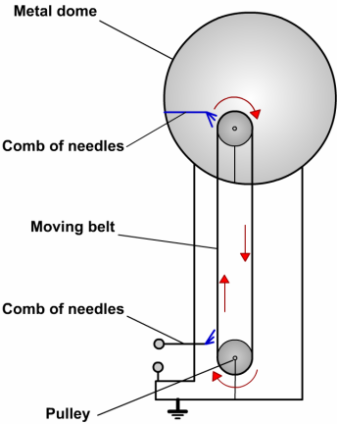
Structure of the atom


History of the atom
- 1890 Thompson proposes plum pudding model; atoms have mostly homogenous distribution of charge and mass
- 1911 Rutherford conducts gold foil experiment; results do not match plum pudding at all, suggest variable distribution of mass and charge
- Rutherford concludes that the atom is mostly empty space with a very small positively charged nucleus and negatively charged electrons orbiting the nucleus
- 1930 neutrons discovered by Chadwick; difficult to detect because they are uncharged


Structure of the atom

The nucleus contains nucleons:
- Protons (p) that are positively charged and carry a mass of 1 atomic mass unit (amu)
- Neutrons (n) that are neutral and carry a mass of 1 amu


Forces in the nucleus
- Protons repel each other because they are all positively charged (electrostatic repulsion)
- The nucleus is held together by the strong nuclear force, a force of attraction acting between all nucleons (protons and neutrons)
- Nuclear force is a very strong short range force (particles are 10-15 m apart). Electrical and gravitational force are long range forces.

Electrons
The negatively charged electrons orbit the nucleus in energy levels. Their mass is so small it is considered negligible (0.00054858 amu).
The electrons are distributed in energy levels :
  - 2 in the first
  - 8 in the second
  - 18 in the third
They move randomly in their allocated space.

Periodic Table
- Atomic No (Z) = no of protons = type of element.
- Atomic Mass No. (A) = no. of protons + no. of neutrons
- No of neutrons = A – Z

^{A}_{Z}X -symbol for element eg ¹³₆C
C = 6 p, 6 e and 7 n

Element | Atomic no. | Mass no. | No. protons | No. neutrons | No. electrons
Li-7 | 3 | 7
 | 13 |  |  | 14
 |  | 89 | 38
 |  |  |  | 140 | 92
He²⁺ |  |  |  | 2

Nuclear masses
- Unified atomic mass units (u)
- Based on relative scale where C-12 atom is given the value of 12.000000 u
- All other atoms mass is relative to C-12.
- Relative atomic mass
- n=1.008665u p = 1.007276 u
- 1u = 1.6605 x 10⁻²⁷ kg H-1 = 1.007825u

Isotopes
- Are atoms of the same element that have a different number of neutrons in their nucleus.
- No. of p and e are the same
- Atomic No the same
- No of neutrons different
- Mass No different.
- Eg C-12, C-13, C-14, C-15, C-16
- Are chemically identical.
- React the same.
- Bond the same.
- Special case; H-1, H-2 deuterium, H-3 tritium
- Radioisotopes – decay releasing radiation.
- Stable isotopes – don’t decay.
- Natural and artificial radioisotopes.

Radiation

Decay of Atoms
Decay of unstable atoms occur when a nucleus falls apart and emits a particle and or high energy rays.
Radioactive isotopes have:
- Too many neutrons compared to protons
- Too many protons compared to neutrons
- Or, they are just too big
A given nucleus is radioactive if it’s outside the band
of stability
By emitting radiation, they become closer to a stable
nucleus
In larger atoms the nuclear force is less effective as distances increase so ratio of neutrons:protons must increase.
- Z <20 n = p
- 20<Z<82 n:p>1
- Z>82 unstable

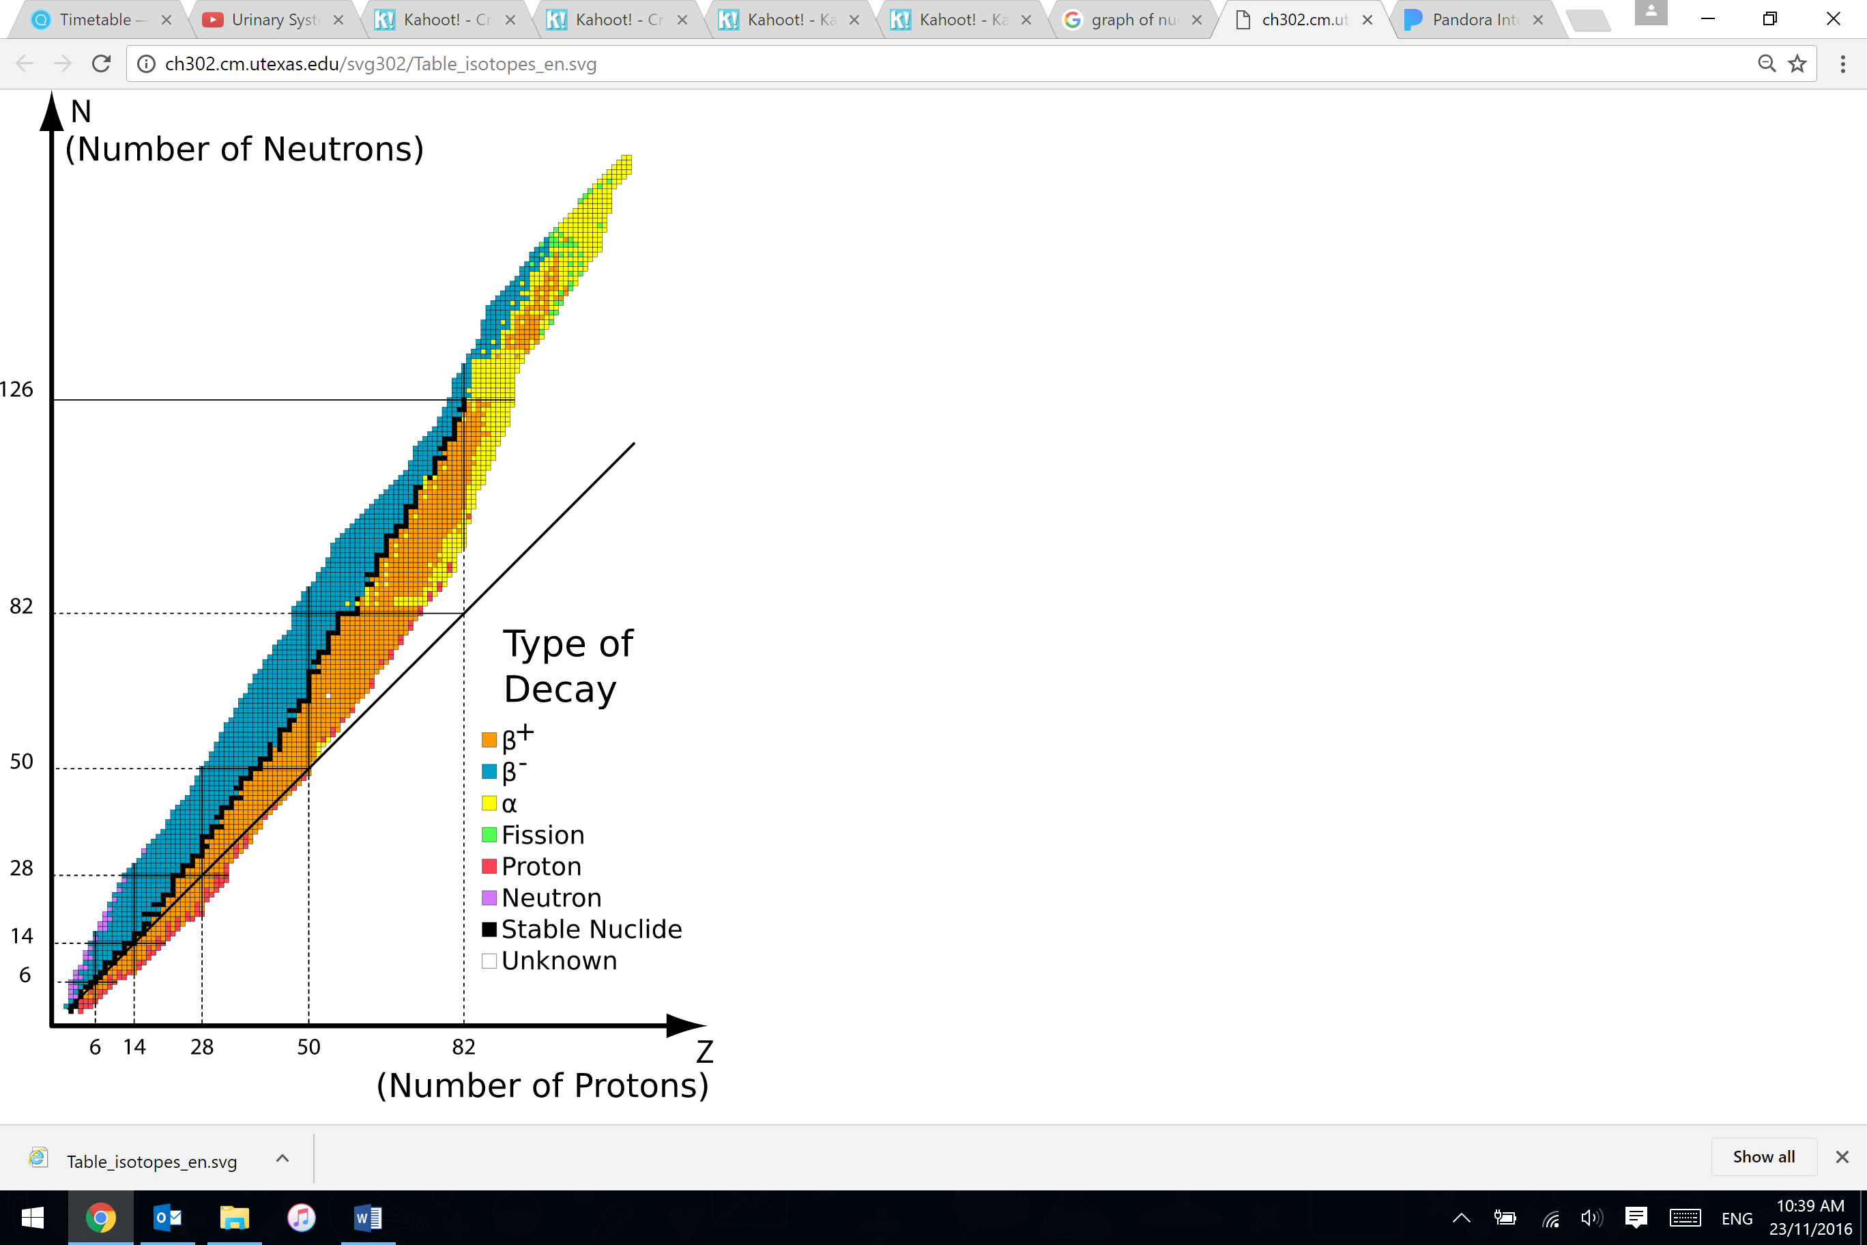
(Stable nuclide, n.d.)

Alpha Decay

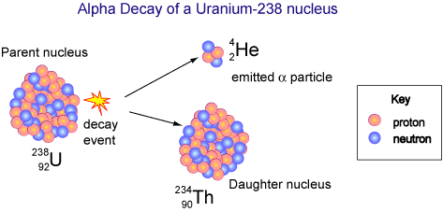

(The Sun: Energy from Nuclei, n.d.)
Alpha Radiation (α)
- α is a helium nuclide.
- Two positive charge
- Travels at 1/10 the speed of light
- Large slow moving particle.
- Very ionising
- Stopped easily by a few cm air, or paper.

Alpha Reactions

²³⁸₉₂U

²²⁶₈₈ Ra

²¹⁰₈₄ Po

- Nuclear equations: conservation of charge and mass.
- Reason: parent nucleus is unstable, nuclear force unable to hold nucleons together.

Alpha Decay Use – Smoke Detector
- The alpha particles emitted by the Am-241 collide with the oxygen and nitrogen in air in the detector's ionisation chamber to produce charged particles called ions.
- A low-level electric voltage applied across the chamber is used to collect these ions, causing a steady small electric current to flow between two electrodes.
- When smoke enters the space between the electrodes, the alpha radiation is absorbed by smoke particles. This causes the rate of ionisation of the air and therefore the electric current to fall, which sets off an alarm.

Beta minus decay (β⁻)
- Beta particle is a nuclear electron.
- A neutron decays into a proton and a beta particle.
- ¹₀n ¹₁p + ⁰₋₁e + ν_{e}
- ¹₀n ¹₁p + ⁰₋₁β + ν_{e}
- Antineutrino particle also released. (Neutral, extremely small mass particle

Beta plus (positron) decay (β⁺)
- Alternatively a positron can be emitted.
- A proton decays into a neutron and a beta particle (and a neutrino).
- ¹₁p ¹₀n + ⁰₁e + ν_{e}
- ¹₁p ¹₀n + ⁰₁β + ν_{e}
- Positron is an antielectron, if a positron encounters an electron they are mutually destroyed releasing gamma rays
- Assume all references to beta decay/radiation are beta minus unless otherwise specified.

Beta radiation (β)
- Travels at 9/10 speed of light.
- Single negative charge.
- Less ionizing ability than alpha.
- Penetrates a few m of air, thin sheet of foil.
- Reason: nucleus is unstable as it has too many neutrons to protons (or too many protons to neutrons for Beta plus decay)

Beta decay reactions

¹⁴₆C

¹⁸⁷₇₅ Re

¹⁸⁷₇₆ Os

- Nuclear equations: conservation of charge and mass.

Beta decay use – Foil thickness
- Beta radiation is able to penetrate thin foil but is blocked by thick foil
- Used to control thickness during production

Beta plus decay uses – Positron Emission Tomography
- Patient injected with a solution containing Fluorodeoxyglucose (¹⁸F)
- Fluorodeoxyglucose mimics glucose so taken into body parts
with high metabolic activity i.e. malignant tumours
- Minimise patient physical activity to stop intake by muscles
- ¹⁸F decays, emitting positrons which mutually destruct with electrons, releasing gamma rays which can be seen by a
camera

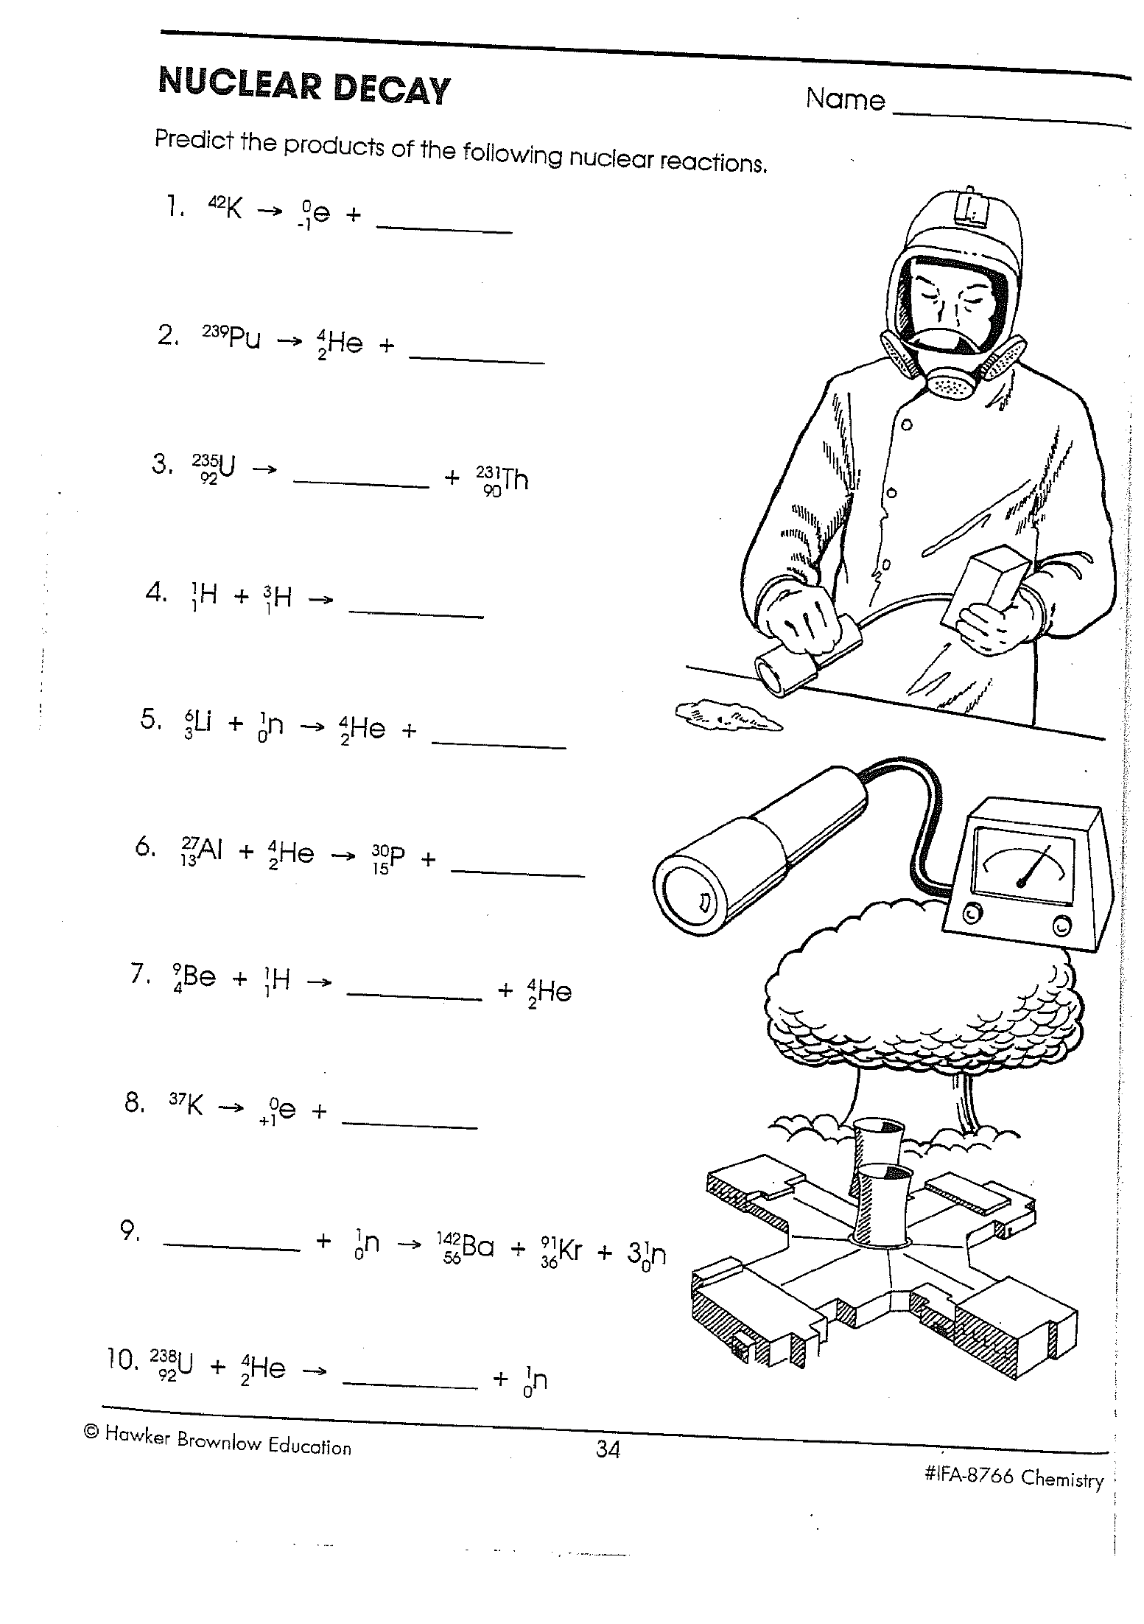
(DiStasio, 2002)
Gamma decay
- Atom in excited unstable state after emission of alpha or beta (or neutron capture).
- Nuclide rearranges itself and releases energy.
- No transmutation on its own, number of protons/neutrons unchanged

Gamma radiation (γ)
- No mass
- No charge
- Travels at speed of light.
- Very penetrating, stopped by 10cm lead
- Not as ionising as other beta/alpha.

Gamma decay reactions

²³⁴₉₁Pa*

^{99m}₄₃ Tc

- Asterisk and ‘m’, both denote excited or metastable nucleus
- Nuclear equations: conservation of charge and mass.

Gamma ray use – Gamma knife
- Many sources of gamma rays placed around head, all aimed at cancer in the brain
- Each individual beam of gamma rays is too weak
to cause significant damage
- The individual beams intersect at the cancer
so it receives a much higher dose of radiation

Neutron radiation
- Neutrons have no electrical charge.
- They have nearly the same mass as a proton (a hydrogen atom nucleus).
- The source of neutrons is primarily nuclear reactions, such as fission, but they may also be produced from the decay of radioactive nuclides.
- Because of its lack of charge, the neutron is difficult to stop and has a high penetrating power.
- Neutrons can be absorbed by nuclides.

Decay Series
- Radioactive atoms can undergo a series of decays ie daughter nuclide decays, granddaughter nuclide decays further.

Detecting radiation – Gieger-Müller tube
- An inert gas-filled tube (Ar) that briefly conducts electricity when a particle or photon of ionising radiation makes the gas conductive by ionising the gas.
- The tube amplifies this conduction by a cascade effect and outputs a current pulse, which is displayed by a needle, lamp and/or audible clicks.
- Geiger detectors are still favoured as general-purpose alpha/beta/gamma portable contamination and dose rate instruments, due to their low cost and robustness.

FARLabs Shielding

Logging on using the FARLabs website:
• On the FAR Labs home page, click on the "Nuclear" button.
• It will open up a page with three tabs ("Turntable", "Inverse-square Law" and "Half-Life") on the
left side of the page.
• Make sure the "Turntable" tab is open and click on the "Explore" button.
• You should see five big green buttons on the left side. Click on the number your teacher has given
you.
• This will open your workstation. Login with your student password and you are ready to begin!
• Clicking the buttons labelled "Source" lines up the detector (called a Geiger counter) with one of
four real radioactive samples.
• Clicking the buttons labelled "Absorber" puts a barrier made of a particular material in between
the source and the detector.
Three very different kinds of radiation come from radioactive materials: - "alpha", "beta" and "gamma". A
radioactive sample of each type can be selected, as well as an "unknown" radiation type which you will try to determine. We are also interested in how the barriers affect the radiation. That is, which barriers can the different types of radiation pass through and which barriers are they unable to pass through. All radioactive emissions are potentially very harmful to humans so it's important to know this.
PART 1: Alpha Radiation
Method:
1. In the column with the Source buttons, click on the “Alpha” source and in the Absorber column,
click on “None”.
2. Make at least five recordings of the counts and make a note in your lab books OR
3. Wait for your Count History graph to record at least 30 seconds of data then create a PNG image.
4. Repeat this process for the Plastic, Thin Aluminium, Thick Aluminium and the Lead barrier (be sure
to leave some time for the graph to stabilise after you change your Absorber).
5. Find the average number of counts for each barrier by averaging your recordings of the counts OR
by ruling a horizontal line on your saved plot that runs through the middle of the points.
Question:
1. What did you notice when you went from no barrier to a barrier?

You may notice that alpha radiation doesn't penetrate barriers much at all. In fact, it turns out that even our skin is enough to stop most alpha radiation. The only way alpha radiation can do damage to humans is if it is inside our body.

PART 2: Beta Radiation
Method:
6. Select the Beta source and Absorber None.
7. Repeat steps 2-5 that you did for the Alpha source.
Question:
2. What do you notice when you go from no barrier to the different kinds of barriers? Was there a
difference between the thin and thick piece of Aluminium?

Radioactive beta material can be safely stored as long as the walls of the container are made thick enough to prevent radiation from escaping. It can also be used to determine the thickness of Aluminium sheets during manufacture by keeping the number of counts at a constant number.
PART 3: Gamma Radiation
Method:
8. Select the Gamma source and Absorber None.
9. Again, Repeat steps 2-5 that you did for the Alpha source.
Question:
3. Does anything affect the average number of counts for gamma
radiation? If so, how?

Gamma radiation is particularly damaging to humans. It can cause cancer and other sickness. The irony is that gamma radiation can also be used to kill cancer cells in cancer patients.

Test your knowledge:
1. Which kind of radiation is the most difficult to contain? Why?
2. Which kind of radiation is the easiest to contain? Why?
3. If you discovered that an Aluminium container of radioactive beta material was still emitting
radiation, how could you reduce the radiation emitted?
4. What do you think the unknown sample is? Alpha, beta or gamma? Can you explain why?
5. Which is the safest kind of radioactive material to handle and why?
6. Gamma radiation is particularly nasty, but can you describe a beneficial use?
7. The unknown sample has been taken from a smoke detector, where there is a radioactive sample a short distance from a radiation detector, which is open to the air. How does a smoke detector work?
Radioactive decay (transmutation) of atoms
- Is a random process
- It is impossible to say when a particular nucleus will decay
- It is only possible to predict what fraction of the radioactive nuclei will decay in a certain time
- Half-life of a radioactive isotope is the average time it takes for half of its atoms to decay.

Half-life t_{1/2}
- The rate of decay depends on the amount of material present, so the decay is exponential
$$N=\frac{N_{0}}{2^{n}}$$

- N = number of remaing undecayed atoms
- N₀ = original number of atoms
- n = no of half lives elapsed
- When N=0.5N₀ then t = t_{1/2}

Activity
- Number of decay events per second
- Measured in Becquerels (Bq)
- 1 Bq = 1 decay per second

$$A=\frac{∆N}{∆t}$$
- As the acitivity depends on the number of atoms in the source, the activity also decays exponentially
- The shorter the half-life of an isotope, the more active it will be
$$A=\frac{A_{0}}{2^{n}}$$
- A sample of Po-218 has an activity of 2000 Bq and a half-life of 3 mins. What is the samples activity after 15 mins?

- In 2 hours the activity of a sample goes from 240 Bq to 30 Bq. What is the samples half-life?

- A compartment on a Geiger Müller tube is filled with a solution containing 1.00g of carbon extracted from one of the Dead Sea scrolls. This gives a count rate of 1000 per hour. When a similar solution containing 1.00 g of carbon extracted from a living plant is used instead, the count rate is 1200 per hour. With no solution in the compartment, the count rate is 300 per hour.
- Estimate the age of the scroll if the half-life of carbon -14 is 5600 years.

Implication of half-life
- Isotopes with long half-lives will have a steady rate of activity over longer time periods and will last a long time therefore suited to long term uses requiring steady activity
- e.g. monitoring foil thickness, smoke detectors
- Isotopes with short half-lives will have a very large activity to start with but will rapidly decay away to nothing therefore suited to short large bursts of radiation where you don’t want to leave anything behind
- e.g. most nuclear medicine uses, one-off uses
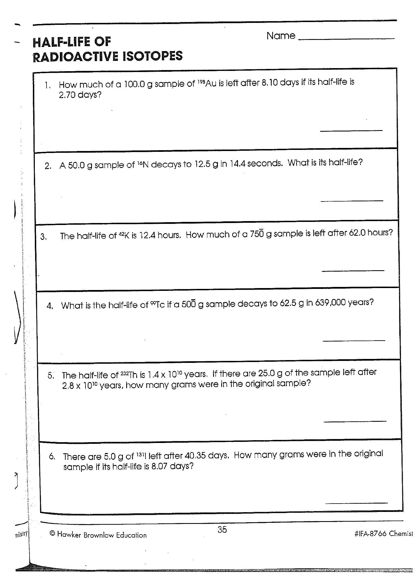

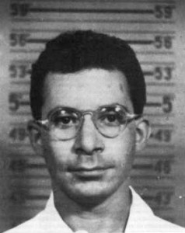
The Louis Slotin Incident (Far Labs, n.d.)
In 1946, to demonstrate to his colleagues how to initiate a nuclear reaction, Canadian physicist Louis Slotin placed two half spheres of Beryllium around a Plutonium core and held them apart with a screwdriver. As he was explaining that; “as long I keep the spheres apart, the reaction will not occur”, the screwdriver slipped and the spheres came in contact! The neutron reflecting Beryllium concentrated the neutrons emitted by the Plutonium core, initiating a fusion reaction. Tragically, the same Plutonium sphere had killed a close colleague only a year earlier.
Slotin died nine days after the accident after a series of agonising symptoms including massive blisters, intestinal paralysis and “a total disintegration of bodily functions”.
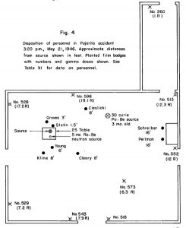
The three people closest to Slotin, Graves, Cieslicki and Young, died of a heart attack, leukaemia and bone marrow disease over the next 30 years. All of those deaths could be linked to the acute radiation poisoning they received that day.

The position of everyone in the room when the Slotin accident occurred.
Those standing further away from the “experiment”, such as Schreiber and Perlman standing by the door, received much less radiation than those at the front. Being three times further away meant they actually received 9 times less radiation, which made the difference between surviving and not surviving.

Test your knowledge:
- If you double the distance away from a radiation source what happens to the radiation counts?
- If the Average Counts is 1000 and you double the distance, how does the number of counts change?
- If the Average Counts is 900 and you triple the distance, how does the number of counts change?
- You are 10 km away from the town of Chernobyl having a picnic with your friends. You check your radiation detector and it says 900 counts. But, 100 is the safe level (oh dear)!! How far away do you tell your friends you need to be to be safe?
- Why do solar panels on Mars need to be larger than on the Earth?
- A solar power cell on a NASA space probe produces 1000 Watts of power when it leaves the Earth. If the space probe needs 10 Watts to keep functioning, how far can it go before it stops working? Hint: the Earth is 150 million km from the Sun, or 1 AU (Astronomical Unit).
- Mars is at 1.5 AU from the Sun, Jupiter 5.2 AU and Saturn 9.5 AU. Can the space probe in question 6 make it to Saturn?
Effects of Radiation
Dangers
- Spread of a radioactive source is more dangerous than spread of radiation itself
- No type of radiation can spread over particularly large distances
- Sources can be carried by water or wind over enormous distance
- Sources will continue to emit over a long time period

Alpha (α)
Does the most damage by:
- Blundering through tissue wreaking havoc on a molecular scale.
- Knocks electrons out of orbit, causing changes to structure of molecule or forming radicals that cause damage.
- Positive charge allows easy access to electrons.
- Size helps in destruction
- Speed limits distance it can travel ( within cell or through a few)

Beta (β)
- Can knock out an electron from orbit as is moving rapidly, even though negatively charged. Ionises molecules.
- Energy delivered heats up cell.
- Quite penetrating

Gamma (γ)
- Form of em radiation with highest energy.
- Can cause ionisation to a lesser degree.
- Gives electrons so much energy they are knocked free from an atom.
- Heats up cells.
- Very penetrating.

Neutron
- No charge so very penetrating
- Can be absorbed by a nucleus potentially destabilising it, causing it to become radioactive itself

Energy of radiation
- Use to approximate danger of exposure
- Measured in electron volts (eV)
- The energy an electron would gain if accelerated by a emf of 1V
- 1eV = 1.6x10⁻¹⁹ J
- Alpha= 5-10 MeV
- Beta = 1.4 MeV
- Gamma= 0.1 MeV

Absorbed Dose
- A 80kg man receiving 200J of energy across his body is at much less risk than a 15kg dog receiving 200J of energy across its body
$$Absorbed dose (Gy) = \frac{energy absorbed (J)}{mass of tissue (kg)}$$
- Absorbed dose accounts for mass, measured in Grays (Gy), equivalent to J kg⁻¹
- Need to consider whether the whole body receives the dose or just one organ
What is the absorbed dose for a man (75kg) and for a boy (25kg) if both received 150J of radiation energy?

Dose Equivalent
- A man receiving 2 Gy of Alpha radiation is not the same as a man receiving 2 Gy of Gamma rays
$Dose Equivalent (Sv)=Absorbed Dose \left(Gy\right)×Quality Factor$
- The damage a type of radiation can cause is not simply proportional to its energy
- Dose Equivalent (Sieverts) accounts for the type of radiation as well, most meaningful way to measure radiation doses

Radiation | Quality Factor
Alpha | 20
Beta | 1
Gamma | 1
Slow Neutron | 3
Fast Neutron | 10

A 10g tumour absorbs 0.002J of energy from an applied radiation source
- What is the absorbed dose?
- Calculate the dose equivalent for an alpha dose:
- Calculate the dose equivalent for a gamma dose:
- Which source is the most damaging to the tumour?

Terrestrial Radiation
- Radioactive materials around us; air, food, ground
- Radon Gas
  - Occurs naturally in atmosphere
  - Decay of U-238
  - Radon not dangerous but daughter products
are as they are solid.
  - Breathe in Radon, daughter products collect
inside you

Effects of radiation
Somatic effects
- Damage to cells that can be passed on to subsequent cells through division
- Very wide range of effects (burns, cancer, anemia, hair loss, radiation sickness)
- Some symptoms present immediately, some are delayed
Genetic effects
- Damage to DNA in sperm or egg cells
- Results in birth defects passed on to the next generation
Deterministic vs Stochastic effects
- Small doses have a small random chance to cause things such as cancer (stochastic effect)
- Doses over a certain threshold are essentially guaranteed to have certain effects (deterministic effect) the severity of these effects increase with size of dose over the threshold
Varies by tissue type
- skin erythema: 2-5 Gy
- irreversible skin damage: 20-40 Gy
- hair loss: 2-5 Gy
- sterility: 2-3 Gy
- cataracts: 5 Gy
- lethality (whole body): 3-5 Gy
- fetal abnormality: 0.1-0.5 Gy

Lethal Dose
- Hard to define simply due to variation between individuals (and a lack of experimental data)
- 1 Sv = severe radiation sickness
- Lethal ld: LD₅₀ = a dose that kills 50% of exposed subjects
- LD₅₀/25 = a dose that kills 50% of exposed subjects in 25 days

Binding Energy
The total mass of a stable nucleus is always less than the sum of the masses of its constituent protons and neutrons.
- ⁴₂He = 4.002602u
- However,
mass of 2 protons (2.017330u) + mass of 2 neutrons (2.0156504u) = 4.032980u.
- Mass difference = 0.030378 u.
- Where is this missing mass?
- It has left in the form of energy (radiation and E_{K}).
- This missing energy is the binding energy
- The total binding energy of the nucleus is related to the difference in the mass of the atom and its constituent nucleons (ie protons and neutrons).
- This is the energy lost by the nucleons when they come together to form a nucleus and is equal to the amount of energy that must be put into a nucleus to break it apart into its constituent nucleons.

Binding energy = change in mass × mass energy equivalence

- Binding energy He = 0.030378u × 931 = 28.3 MeV of energy.

Mass energy equivalence e=mc²

Binding energy per nucleon
- A greater binding energy per nucleon = a greater stability of the nucleus
- Average binding energy per nucleon = total binding energy / # nucleons
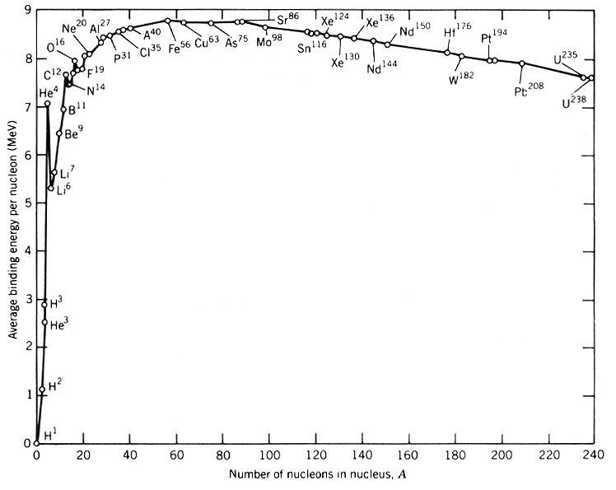
- E.g. He = 28.3/4 = 7.07 MeV nucleon⁻¹
(432, 2016)
Iron-56 example
- Fe-56 is the maximum binding energy per nucleon
- Therefore, most stable nucleus
- Calculate the total binding energy for Fe-56 and its binding energy per nucleon. The mass of Fe-56 is 55.9349375 u.
- Fe-56 has 26 protons (p) and 30 neutrons (n).
- See data sheet for mass of protons and neutrons

Fusion and fission
- Fusion and fission can both release energy despite being opposite reactions
- Energy is released from a nuclear reaction if the average binding energy per nucleon increases in the reaction
- Any reaction moving towards Fe-56 will therefore release energy

Nuclear Power
Fission
- Nuclear fission occurs when an atomic nucleus splits into 2 or more pieces. This is often triggered by the absorption of a neutron
- Fissile material = nuclides that are capable of undergoing nuclear fission after absorbing a neutron.
- Eg : U-235 and Pu-239 = readily fissile
- U-238 and Th-232 = slightly fissile with a high energy neutron.

Uranium
- Natural uranium is 99.284% U-238 isotope, with U-235 only constituting about 0.72 % of its weight.
- U-235 is the only isotope existing in nature (in any appreciable amount) that is fissionable by thermal (slow) neutrons.
- Enriched uranium is a sample of uranium in which the percent composition of uranium-235 has been increased through the process of isotope separation.
- Enriched uranium is a critical component for both civil nuclear power generation and military nuclear weapons. The U -238 remaining after enrichment is known as depleted uranium (DU), and is considerably less radioactive than even natural uranium, though still extremely dense. It is useful for armour, penetrating weapons, and other applications requiring very dense metals.

Grade of enrichment
- Slightly enriched uranium (SEU) has a U-235 concentration of 0.9% to 2%. Used in heavy water reactors like the CANDU.
- Low-enriched uranium (LEU) has a lower than 20% concentration of U-235. Use in commercial light water reactors (LWR) - 3 to 5 % U-235. Research reactors -12% to 19.75% U-235,
- Highly enriched uranium (HEU) has a greater than 20% concentration of U-235 or U-233.
- The fissile uranium in nuclear weapons usually contains 85% or more of U-235 - weapon(s)-grade

Enrichment process
- Enrichment use the slight differences in atomic weights of the various isotopes.
- The gas centrifuge process uses a large number of rotating cylinders in series and parallel formations. This rotation creates a strong centrifugal force so that the heavier gas molecules containing U-238 move toward the outside of the cylinder and the lighter gas molecules rich in U-235 collect closer to the centre.

Fission of U-235
- Several possible reactions
- On average 2.5 neutrons are released
- ¹₀n +²³⁵₉₂U → ²³⁶₉₂U → ⁹¹₃₆ Kr + ¹⁴²₅₆Ba +3¹₀n
- U-235 requires a slow neutron but reaction releases fast neutrons.
- Amount of energy released is 200 MeV in the form of kinetic energy, gamma rays and heat.
- This energy originates from mass being converted into energy: E = mc²

Chain reaction
- Fission is triggered by a neutron and releases more neutrons, can become self-sustaining
- Each fission must produce at least one neutron that will trigger a further fission
- Any given neutron could be:
  - Lost
  - Abosrbed without reaction
  - Absorbed causing fission

Critical mass
- Critical mass is the minimum mass required for the reaction to become self-sustaining, is shape dependent (amongst other factors)
- Sphere gives smallest critical mass, smallest SA:V, fewest number of neutrons lost
- Sub-critical mass: cannot sustain chain reaction
- Critical mass: self-sustaining chain reaction occurring at constant rate (reactors)
- Super-critical mass: runaway chain reaction occurs at increasing rate (weapons)

- ¹₀n + ²³⁹₉₄Pu → ¹⁴⁵₅₆Ba + ⁹³₃₈Sr + ___¹₀n
- ¹₀n + ²³⁹₉₄Pu → _______ + ⁹²₃₆Kr + 2 ¹₀n

- Calculate for following reaction:
- ¹₀n +²³⁵₉₂U → ²³⁶₉₂U → ⁹²₃₆ Kr + ¹⁴¹₅₆Ba +3¹₀n
- Mass defect
- Masses: U-235 = 235.04393u, Ba-141 = 140.91440, Kr-92 = 91.92630u n = 1.00866u.
- Energy released per U atom in J and MeV
- Energy released by 1 kg of U-235 all fission

Thermal nuclear reactors
- Attempt to maintain a steady sustained fission chain reaction in the fuel
- Energy released heats water, creating steam to turn a turbine creating electricity


(Nuclear 1, n.d.)
5 problems
- Fission produces fast neutrons but is triggered by slow neutrons
- Solution: Moderator, a material that slows down the neutrons
- Good moderators slow neutrons without absorbing them (water, graphite, heavy water, CO₂
- Release of 2-3 neutrons per fission will result in an uncontrolled runaway chain reaction, need to control number of neutrons in system
- Solution: Control rods, material that absorbs neutrons (cadmium, boron steel) that can be inserted or retracted as needed to control number of neutrons present
- Natural U is only 0.7% U-235, need more to sustain chain reaction
- Solution: enrich fuel to 2.3% U-235
- Fuel rods are thin Al tubes containing spherical pellets of enriched U, 1000 in a reactor, last 4 years
- Heat produced has to be collected and diverted to generate electricity
- Solution: pipes containing coolant (liquid sodium, water, CO₂ or heavy water)
- Generates dangerous neutron and gamma radiation, have to protect workers
- Solution: 2m thick casing around core made of layers of concrete, graphite, steel and lead to reflect and absorb radiation, workers are monitored

Fusion
- Nuclear fusion occurs when two small atomic nuclei fuse to form a new heavier nucleus
- Occurs in stars, source of their heat
- Forms heavier elements from light elements
- deuterium + tritium → helium-4 + neutron (masses in STAWA pg 80)

Nuclear Technology Revision for Topic Test and Exam

- a) What is an isotope? Explain with examples.
b) How many protons and neutrons in:
i)
ii)
iii)
- An isotope of oxygen-16 has a nuclear mass of 15.9994 u. Calculate its mass defect and its binding energy.
- Discuss the nuclear changes which take place when each of the following is emitted form the nucleus. Also state their ionisation abilities and penetrating power.
- Alpha particle d) positron
- Beta particle e) neutron
- Gamma ray.
- Would energy need to be supplied or released when the following reaction takes place? How much energy is involved in the reaction?
Li-6 + alpha particle Be-9 + H-1
Mass: Li- 6 = 6.01512u
He-4 = 4.002602u
Be-9 = 9.012182u
H-1 = 1.007825u

- The isotope of hydrogen called deuterium has a nuclear mass of 2.0140 u. Calculate its mass defect and total Binding energy and its binding energy per nucleon.

- Complete each of the following decay equations:
- y

- Write the equation for:
- the fusion of deuterium and tritium. One of the products is alpha particle. Name any other products produced.
- Proton bombardment of boron-11 that results in the release of an alpha particle.
- Neutron bombardment of rhodium-104 that results in the release of a gamma ray.

- Find the mass defect and the energy in J released in the following reactions ( use constant sheet values in kg)
m_{H-1}= 1.007825
m_{H-2}= 2.014101
m_{H-3}= 3.016049
m_{He-4}= 4.002603
- ${}_{1}^{2}H+{}_{1}^{2}H→{}_{1}^{3}H+{}_{1}^{1}H$

- Determine what X is in the following. Use the periodic table where necessary.

- An industrial physicist accidently swallows a radioisotope with an activity of
10.0 kBq. The material has a very long half-life and its activity will not change appreciably during the physicist’s life. Each decay releases 1.6 x 10⁻¹³J of energy into the body. Assume all energy is absorbed by the body and the isotope is not eliminated from the body.
a) Determine the amount of energy absorbed in one year (365 days)
b) Estimate her absorbed dose in 1 year?
c) If the isotope releases gamma rays what is her dose equivalent?
d) How will she be affected?

- In the course of a year-long project a radiologist operated a gamma camera, which contained a source with an activity of 15 kBq for two hours every day. Due to faulty shielding a Phillipa was exposed to a full dose of radiation for the duration of the research. If each decay releases 1.3 x 10 ⁻¹³ J:
- Determine the amount Phillipa receives in 1 year.
- Given that Phillipa’s mass is 80 kg, determine her absorbed dose4 in one year in grays.
- Determine her dose equivalent in 1 year in mSv.
- Should she be concerned over her level of exposure? Explain.

- a) Define the term ‘binding energy’
b) Calculate the binding energy of oxygen -17 in Joules.
Mass of: O-17 = 16.994740 u
Proton = 1.007276u
Neutron = 1.008625 u

- The reaction:
- Calculate the energy released due to the decay of one atom of Pu-239.

Atomic mass of: Pu-239 239.052157u
U-235 235.043924 u
He-4 4.002600 u
- Determine the energy released in joules when 1 kg of Pu atoms decay (assume all atoms decay)

- A 100MW nuclear reactor is operating at 50% of its maximum power output. The reactor uses fissile uranium-235 fuel, a water moderator and cadmium control rods.
- What would be the effect on the power output if the control rods were slowly withdrawn from the reactor core? Explain.
- What would be the effect on the power output if the moderator was ‘removed’ from the core? Explain.

- Write the nuclear equation for the alpha decay of U-234.

- Suggest a sequence you could use to change mercury-200 isotope into gold-196. Write the equations for the reactions.

- The radioactive isotope phosphorous-32 has a half-life of 14.3 days and decays to form a stable product. A nuclear technician prepares a sample of P-32 with an initial activity of 2.4 x 10 ⁶ Bq. What is the activity of P-32 after 42.9 days?

- The gold isotope, gold-198 that engineers use to track sewage, is a beta emitter with a half-life of 2.7 days.
- If the original activity of a particular sample is 8MBq, what is the activity after 7 days?
- What is its equation for its decay?
- Sketch a rough graph of activity against time.

- Carbon-14 is a radioactive isotope of carbon present in the tissue of all living organisms. The ratio of C-12 to C-14 in living things is the same as the ratio in the earth’s atmosphere. Why is there less C-14 in old animal bone compared to the same mass of new bone?

- How old is a bone where the C-14 to C-12 ratio is 1/20th of the value in living organisms half-life for C-14 is 5730 years.

- Calculate the binding energy of deuterium and it s BE/nucleon.
Mass H-2 2.014000 u

- As a Minister for energy and the environment submit a report to govt convincing them that a nuclear power station would cater for the states growing needs for energy better than a coal-powered fire station. List your main points.

- Write the equation for the:
- Proton bombardment of boron-11 that results in the release of an alpha particle.
- Neutron bombardment of rhodium-104 that results in the release of a gamma ray.

- Which type of radiation would you use for the following? Explain.
- Radiation therapy of a tumour.
- Smoke detector
- Controlling thickness of aluminium foil
- Detecting a leaking pipe
- Radioisotope injected into patient to destroy targeted cancer cells.
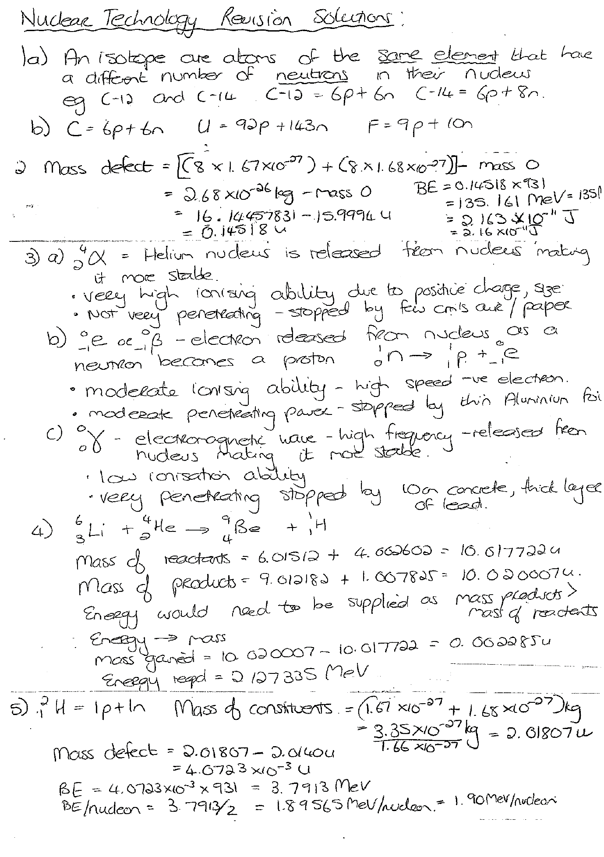

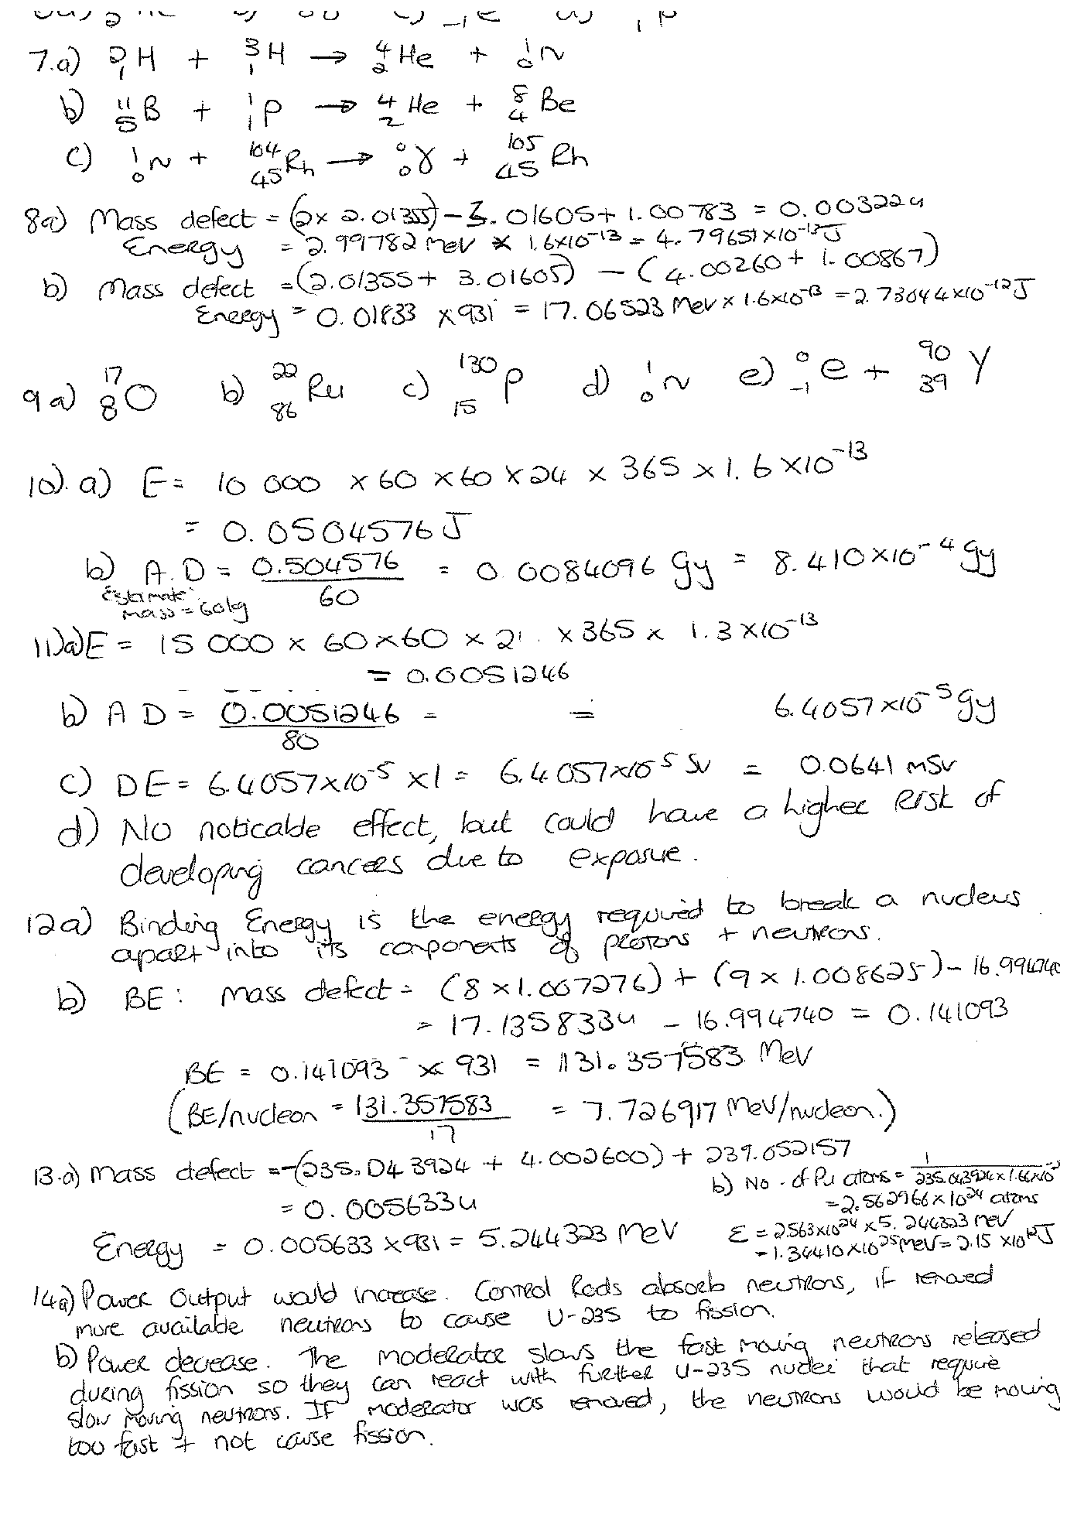
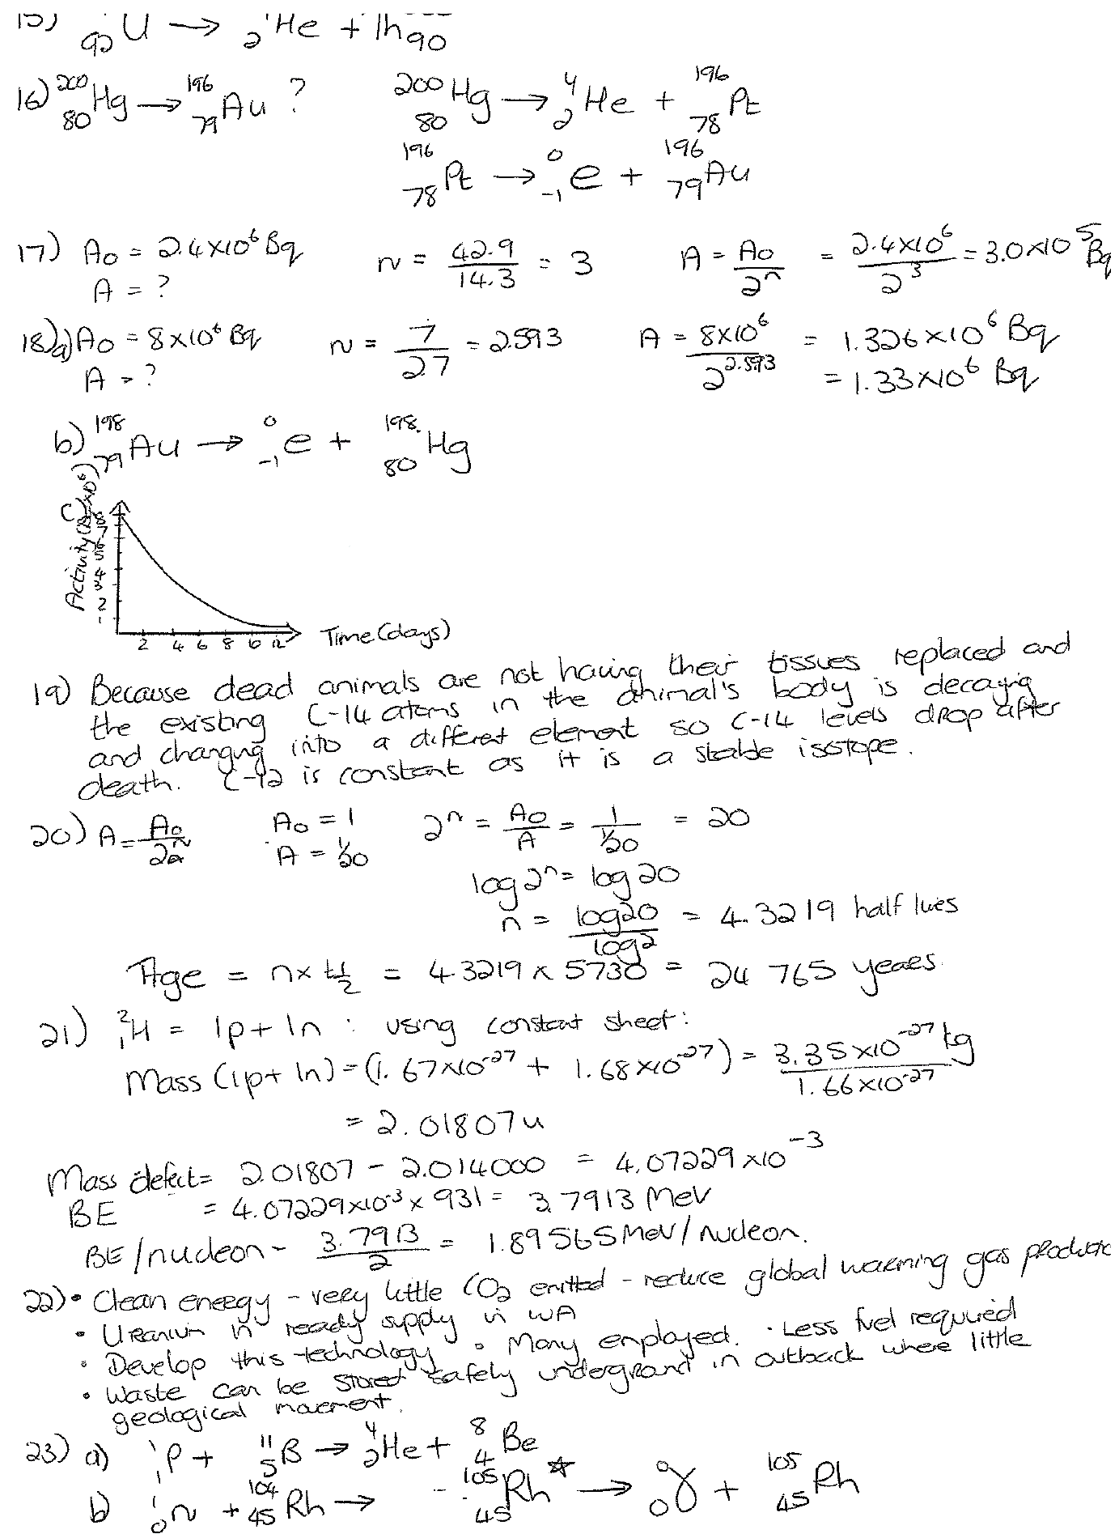

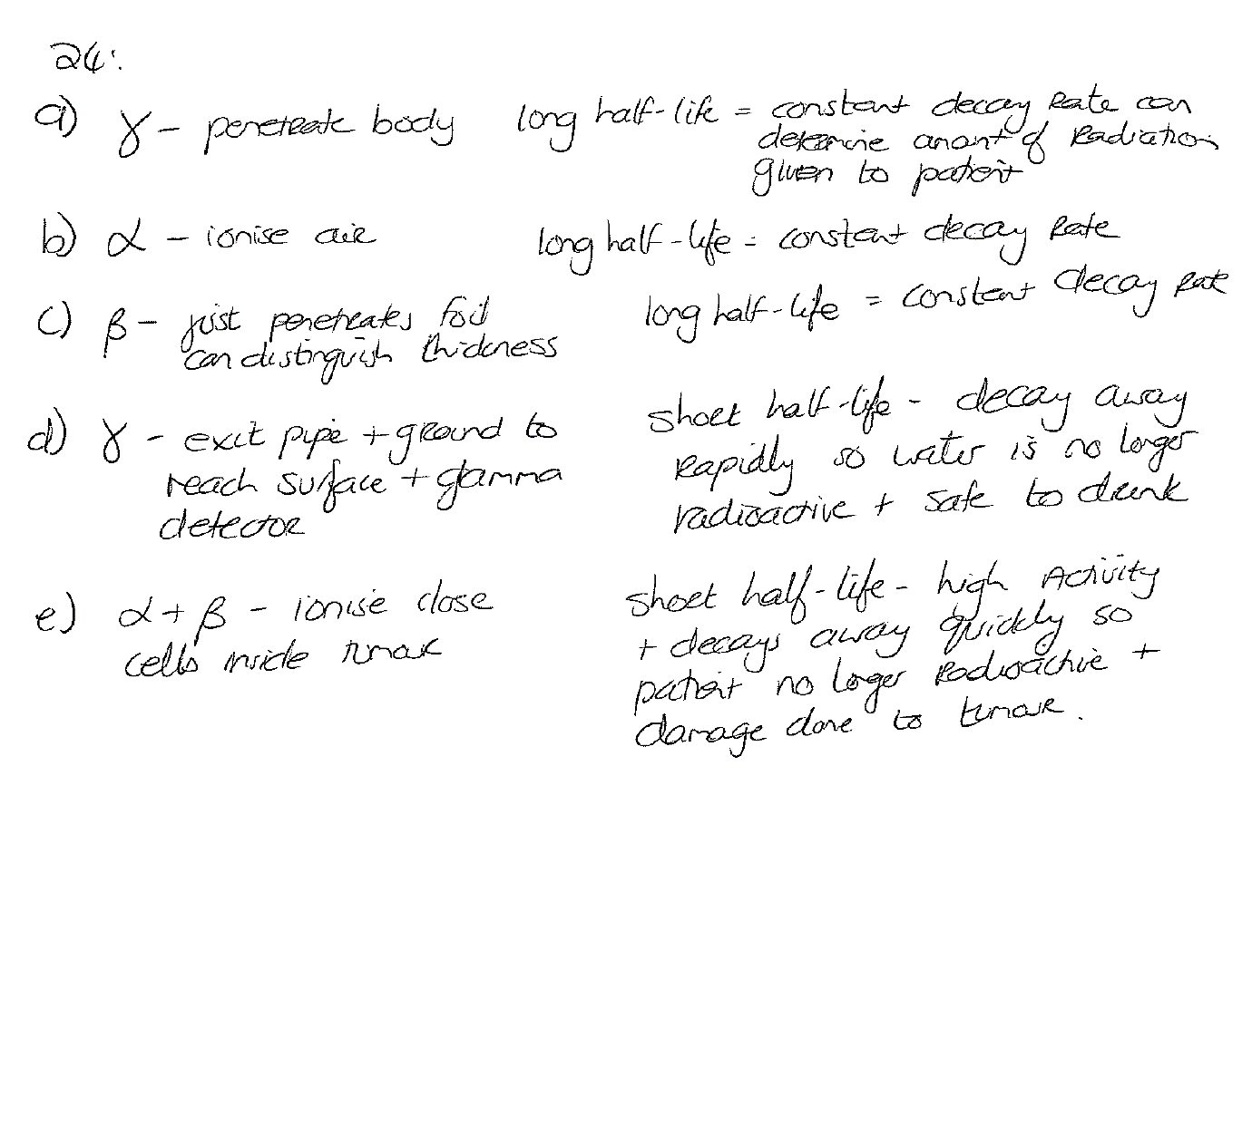

References
(n.d.). Retrieved from Slide player: http://slideplayer.com/slide/4442442/
(n.d.). Retrieved from Far Labs: https://www.farlabs.edu.au/
432, G. (2016, May 4). Binding energy per nucleon trend for fusion vs fission. Retrieved from Physics Forums: https://www.physicsforums.com/threads/binding-energy-per-nucleon-trend-for-fusion-vs-fission.870284/
bibliotecapleyades.net. (n.d.). Retrieved from Tesla coil: http://www.bibliotecapleyades.net/imagenes_tesla/tesla17_02.gif
DiStasio, J. (2002). 100 Hands-on Chemistry Activities. Cheltenham: Hawker Brownlow Education.
Nuclear 1. (n.d.). Retrieved from Energy site: http://www.oocities.org/energy_site/Nuclear1.htm
Puiu, T. (2017, September 28). The explosive difference between nuclear fission and fusion. Retrieved from ZME Science: https://cdn.zmescience.com/wp-content/uploads/2017/09/nuclear_fission.jpg
Stable nuclide. (n.d.). Retrieved from Wikipedia: https://en.wikipedia.org/wiki/Stable_nuclide
The Sun: Energy from Nuclei. (n.d.). Retrieved from Australia Telescope National Facility: https://www.atnf.csiro.au/outreach/education/senior/cosmicengine/sun_nuclear.html
Thermometer Clip Art - Image #8708. (n.d.). Retrieved from Clip art: http://cliparting.com/free-thermometer-clip-art-8708/

